**Cystic Fibrosis**

Cystic fibrosis (CF) is a genetic (inherited) disease that causes sticky, thick mucus to build up in organs, including the lungs and the pancreas. In people who have CF, thick mucus clogs the airways and makes it difficult to breathe. Management includes ways of clearing lungs and a nutrition plan.

**Overview**

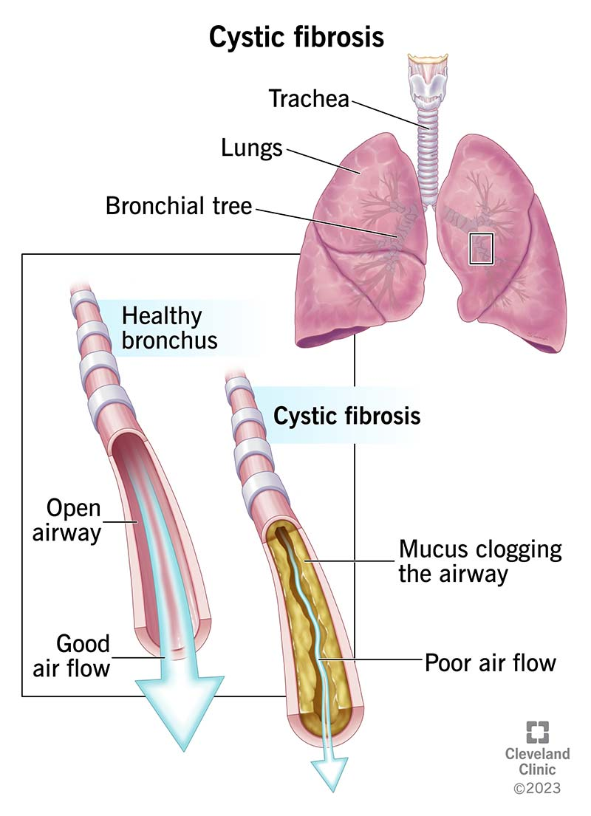The thick mucus caused by cystic fibrosis can block your airways, causing frequent infections and difficulty breathing.

**What is cystic fibrosis (CF)?**

Cystic fibrosis (CF) is a genetic disease that causes sticky, thick mucus to build up in your organs, blocking and damaging them. Many people think of CF as a [lung](https://my.clevelandclinic.org/health/body/8960-lungs) disease because it affects your lungs and airways, which can make it hard to breathe and cause frequent infections. But it’s called cystic fibrosis because it also causes cysts and scarring (fibrosis) in your [pancreas](https://my.clevelandclinic.org/health/body/21743-pancreas). This damage, plus the thick mucus, can block ducts that release digestive [enzymes](https://my.clevelandclinic.org/health/articles/21532-enzymes), making it hard to get nutrients from your [digestive tract](https://my.clevelandclinic.org/health/body/7041-digestive-system). CF can also affect your liver, sinuses, intestines and sex organs.

The mucus that lines your organs and body cavities, such as your lungs and nose, is thin and watery. In people with CF, a change in a gene ([genetic mutation](https://my.clevelandclinic.org/health/body/23095-genetic-mutations-in-humans)) leads to low levels of certain proteins, or proteins that don’t work properly. Because of these faulty proteins, minerals that move water into your mucus (which thins it out) get trapped inside cells, leaving the mucus thick and sticky.

People with cystic fibrosis are born with it. It’s a lifelong illness that gets more severe over time. Most people with CF don’t live as long as people without it.

**Types of cystic fibrosis**

There are two types of cystic fibrosis:

* **Classic cystic fibrosis** often affects multiple organs. It’s usually diagnosed in the first few years of your life.
* **Atypical cystic fibrosis** is a milder form of the disease. It may only affect one organ or symptoms may come and go. It’s usually diagnosed in older children or adults.

**Symptoms and Causes**

**What are the symptoms of cystic fibrosis (CF)?**

Cystic fibrosis symptoms include:

* Frequent lung infections (recurrent [pneumonia](https://my.clevelandclinic.org/health/diseases/4471-pneumonia) or [bronchitis](https://my.clevelandclinic.org/health/diseases/3993-bronchitis)).
* Loose or oily poop (stool).
* Trouble breathing.
* Frequent [wheezing](https://my.clevelandclinic.org/health/symptoms/15203-wheezing).
* Frequent [sinus infections](https://my.clevelandclinic.org/health/diseases/17701-sinusitis).
* A nagging cough.
* Slow growth.
* Failure to thrive (inability to gain weight despite having a good appetite and taking in enough calories).

**Atypical cystic fibrosis symptoms**

People with atypical cystic fibrosis may have some of the same symptoms as those with classic CF. Over time, you also might experience:

* [Chronic sinusitis](https://my.clevelandclinic.org/health/diseases/17700-chronic-sinusitis).
* [Nasal polyps](https://my.clevelandclinic.org/health/diseases/15250-nasal-polyps).
* [Dehydration](https://my.clevelandclinic.org/health/diseases/9013-dehydration) or [heatstroke](https://my.clevelandclinic.org/health/diseases/21812-heatstroke) from abnormal [electrolyte](https://my.clevelandclinic.org/health/diagnostics/21790-electrolytes) levels.
* [Diarrhea](https://my.clevelandclinic.org/health/diseases/4108-diarrhea).
* [Pancreatitis](https://my.clevelandclinic.org/health/diseases/8103-pancreatitis).
* [Unintended weight loss](https://my.clevelandclinic.org/health/diseases/17770-unexplained-weight-loss).

**What causes cystic fibrosis?**

Changes to the *CFTR* gene — called variants or mutations — cause cystic fibrosis. *CFTR* makes a protein that works as an ion channel on the surface of a cell. Ion channels are like gates in a cell’s membrane that allow certain molecules to pass through.

*CFTR*usually makes a gate for chloride ions, a type of mineral with a negative electrical charge. Chloride moves out of the cell, taking water with it, which thins out mucus and makes it more slippery. In people with CF, gene mutations in *CFTR* prevent this from happening, so the mucus stays sticky and thick.

There are different categories (classes I to VI) of gene mutation in *CFTR*that depend on the effect they have. Some produce no proteins at all, some produce only small amounts of proteins, and some produce proteins that don’t work properly.

**Are you born with cystic fibrosis?**

Yes, cystic fibrosis is a genetic condition that you’re born with. People who have CF inherit two mutated *CFTR* genes, one from each biological parent (it’s inherited in an [autosomal recessive](https://my.clevelandclinic.org/health/body/23078-autosomal-dominant--autosomal-recessive) manner).

Your parents don’t have to have cystic fibrosis for you to have CF. In fact, many families don’t have a family history of CF. Someone with just one copy of the gene variant is called a carrier. About 1 in 31 people in the U.S. are carriers who have no CF symptoms.

**Can adults get cystic fibrosis?**

You’re born with the mutation in the gene that causes cystic fibrosis. But with mild symptoms, or symptoms that come and go, some people may go undiagnosed until later in life, even as adults.

**What are the complications of CF?**

Complications of CF include:

* [**Infections**](https://my.clevelandclinic.org/health/diseases/24189-bacterial-infection)**.** Thick mucus can trap bacteria in your lungs and airways that you can’t clear out. This can lead to frequent infections.
* **Congenital bilateral absence of the vas deferens (CBAVD).** In this condition, [males](https://my.clevelandclinic.org/health/articles/sex-recorded-at-birth) don’t have the vas deferens (sperm ducts). They often need the help of fertility procedures if they want to have biological children.
* [**Diabetes**](https://my.clevelandclinic.org/health/diseases/7104-diabetes)**.** Damage to your pancreas can cause cystic fibrosis-related diabetes.
* [**Malnutrition**](https://my.clevelandclinic.org/health/diseases/22987-malnutrition)**.**Thick mucus in your digestive tract and the lack of pancreatic enzymes to help you digest can put you at risk for malnutrition.
* [**Osteopenia**](https://my.clevelandclinic.org/health/diseases/21855-osteopenia)**and**[**osteoporosis**](https://my.clevelandclinic.org/health/diseases/4443-osteoporosis)**.** The inability to absorb nutrients in your digestive tract can lead to conditions that make your bones too thin.
* [**Pregnancy complications**](https://my.clevelandclinic.org/health/articles/24442-pregnancy-complications)**.** CF can affect your digestive tract and cause poor nutrition. This can increase your risk of pregnancy complications. Preterm (early) birth is the most common complication.

**Diagnosis and Tests**

**How is cystic fibrosis diagnosed?**

Healthcare providers often test for cystic fibrosis during a newborn screening. Providers perform this test with a few drops of blood from your baby’s heel. A lab looks in the blood sample for immunoreactive trypsinogen (IRT), a chemical made in your pancreas. People with CF have higher levels of IRT in their blood. Babies are often tested for IRT shortly after birth and a few weeks later.

Some conditions — like preterm delivery — can raise IRT levels. So, a positive IRT test alone doesn’t mean your baby has CF. If your baby has higher levels of IRT than expected, your healthcare provider will order additional tests to make a final diagnosis.

In about 5% of cases, the newborn screen doesn’t detect elevated IRT levels in someone with CF. Or you may have been born before routine CF screening was available. If you or your child has symptoms of CF, a provider will perform a sweat test and follow up with additional tests as needed.

**Tests for cystic fibrosis**

* [**Sweat test**](https://my.clevelandclinic.org/health/diagnostics/17856-sweat-test-for-cystic-fibrosis-cf)**.** The sweat test measures the amount of chloride in your body’s sweat. Chloride levels in sweat are higher in people who have CF. This is the most conclusive test for CF, but it may be normal in people with atypical CF.
* [**Genetic tests**](https://my.clevelandclinic.org/health/diagnostics/23065-dna-test--genetic-testing)**.**A provider tests blood samples for changes in the genes that cause CF.
* **Imaging.** Providers use imaging, like sinus and [chest X-rays](https://my.clevelandclinic.org/health/diagnostics/10228-chest-x-ray), to support or confirm a CF diagnosis. Imaging alone can’t diagnose CF.
* [**Pulmonary function tests**](https://my.clevelandclinic.org/health/diagnostics/17966-pulmonary-function-testing)**.** These tests measure how well your lungs are working.
* [**Sputum culture**](https://my.clevelandclinic.org/health/diagnostics/25174-sputum-culture)**.** Your healthcare provider takes a sample of your sputum (mucus coughed up from your lungs) and tests it for bacteria. Certain bacteria, such as *Pseudomonas*, are most commonly found in people who have CF.
* **Pancreatic**[**biopsy**](https://my.clevelandclinic.org/health/diagnostics/15458-biopsy-overview)**.** This can tell your provider if you have cysts or damage to your pancreas.
* **Nasal potential difference (NPD).** This test measures the small amount of electrical charge that’s usually present in the lining of your nose. The movement of ions creates this charge. People with CF don’t have as much ion movement because of the way CF affects their ion channels.
* **Intestinal current measurement (ICM).** A provider takes a sample of rectal tissue to perform this test. A lab uses the sample to measure how much chloride it secretes.

**Management and Treatment**

**How do you treat cystic fibrosis?**

There’s no cure for cystic fibrosis. You can manage the disease and its symptoms with the help of a cystic fibrosis specialist and other providers on your healthcare team. Management involves:

* Keeping your airways clear and open with breathing techniques and devices to loosen mucus.
* Medications that help correct issues with CFTR proteins (CFTR modulators).
* Medications that reduce specific symptoms.
* Ensuring you get enough of the right kinds of calories from food.
* Surgery.

**Airway clearance techniques**

You can help to keep your airways clear if you have cystic fibrosis in a number of ways:

* **Coughing and breathing techniques**. A [physical therapist](https://my.clevelandclinic.org/health/articles/24625-physical-therapist) who specializes in CF can teach you techniques that open your airways and loosen mucus.
* **Positive expiratory pressure (PEP).** PEP devices fit in your mouth or with a mask on your face. They provide resistance so you have to work harder to breathe out, holding your airways open and forcing out mucus. Oscillating PEP devices (Flutter®, Acapella®, AerobikA®, RC-Cornet®) are specific types of PEP that also vibrate to loosen mucus.
* **Airway clearance vests.** An airway clearance vest, or high-frequency chest wall oscillation device, is an inflatable vest that attaches to a machine. The vest vibrates to loosen mucus.
* **Postural drainage and percussion.** This is a type of physical therapy where you move into certain positions so that your lungs can drain. Another person claps their hand on your chest and/or your back to help loosen the mucus. You might combine this with coughing techniques.

**CFTR modulators for cystic fibrosis**

CFTR modulators are medications that can help correct issues with proteins made by mutated *CFTR* genes and increase the amount of functioning proteins on your cells’ surfaces. They’re not a cure for CF. But for certain people, they’ve made dramatic improvements in symptoms and life expectancy. Despite this, some people with CF don’t qualify for or can’t tolerate modulator therapies.

CFTR modulators include:

* [Kalydeco®](https://my.clevelandclinic.org/health/drugs/19328-ivacaftor-oral-tablets) [(ivacaftor)](https://my.clevelandclinic.org/health/drugs/19328-ivacaftor-oral-tablets).
* [Orkambi®](https://my.clevelandclinic.org/health/drugs/19254-lumacaftor-ivacaftor-tablets) [(ivacaftor/lumacaftor)](https://my.clevelandclinic.org/health/drugs/19254-lumacaftor-ivacaftor-tablets).
* [Symdeko®](https://my.clevelandclinic.org/health/drugs/21440-tezacaftor-ivacaftor-oral-tablets) [(ivacaftor/tezacaftor)](https://my.clevelandclinic.org/health/drugs/21440-tezacaftor-ivacaftor-oral-tablets).
* [Trikafta®](https://my.clevelandclinic.org/health/drugs/21375-elexacaftor-tezacaftor-ivacaftor-oral-tablets) [(ivacaftor/tezacaftor/elexacaftor)](https://my.clevelandclinic.org/health/drugs/21375-elexacaftor-tezacaftor-ivacaftor-oral-tablets).

**Other medications for cystic fibrosis**

Your provider may also prescribe medications that reduce inflammation, treat infections or manage symptoms. These include:

* [**Antibiotics**](https://my.clevelandclinic.org/health/treatments/16386-antibiotics)**.** Your provider might give you antibiotics to treat or prevent infections.
* [**Inhaled bronchodilators**](https://my.clevelandclinic.org/health/treatments/17575-bronchodilator)**.** Bronchodilators make breathing easier by opening and relaxing your airways.
* **Inhaled hypertonic saline.** The salt in saline solutions attracts water, which thins mucus and makes it easier to clear.
* **Anti-inflammatory drugs.** These medications reduce swelling. They include [corticosteroids](https://my.clevelandclinic.org/health/drugs/4812-corticosteroids) and [nonsteroidal anti-inflammatory drugs (NSAIDS)](https://my.clevelandclinic.org/health/treatments/11086-non-steroidal-anti-inflammatory-medicines-nsaids).
* **Pancreatic enzymes.**These help you digest food and get nutrients from it.
* [**Stool softeners**](https://my.clevelandclinic.org/health/drugs/23274-stool-softener)**.** These can help with constipation and make it easier to poop.

**Cystic fibrosis diet**

If you have CF, your dietary needs are different from those of someone without CF. CF can prevent your pancreas from creating or secreting enzymes that help break down food. This means your intestines don’t fully absorb nutrients and fats from foods.

Your CF specialist or a registered [dietitian](https://my.clevelandclinic.org/health/articles/dietitian) may recommend a nutrition plan. It could include:

* **Taking in extra calories each day.** This might be up to twice as many calories as someone without CF.
* **Eating foods that are high in fat.** This is important in helping you get more fat-soluble vitamins.
* **Maintaining a higher-than-typical weight starting in childhood.** This can help you grow taller and have larger lungs, which can help with symptoms as you grow.
* **Taking enzyme supplement capsules**. Enzyme supplements help you digest foods.
* **Increasing your salt intake.** This helps to replace excess salt you lose when sweating. This is especially important during hot, humid weather and exercise. Ask your provider about the amount of salt you need each day.

**Surgeries for cystic fibrosis**

You may need surgery for cystic fibrosis or one of its complications. These might include:

* Surgery on your nose or sinuses.
* Bowel surgery to remove blockages.
* [Lung transplant](https://my.clevelandclinic.org/health/treatments/23044-lung-transplant).
* [Liver transplant](https://my.clevelandclinic.org/health/treatments/8111-liver-transplantation).

**Prevention**

**Can you prevent CF?**

Since you’re born with CF, there’s no way to prevent it. If you’re a carrier of a *CFTR*gene variant, you can ask your provider about [prenatal genetic testing](https://my.clevelandclinic.org/health/diagnostics/24136-pregnancy-genetic-testing) and the chances that your biological children would have CF.

**Outlook / Prognosis**

**Is cystic fibrosis a life-threatening condition?**

Yes, cystic fibrosis can be life-threatening. Lung damage — from thick mucus and frequent lung infections — is the most common cause of death.

**What is the life expectancy of cystic fibrosis?**

Experts predict the [life expectancy](https://www.ncbi.nlm.nih.gov/pmc/articles/PMC9004282/) of someone born with cystic fibrosis in the past few years is around 50 years old. Improvements in treatment in recent years have increased this from a few years ago, when life expectancy was between 30 and 40 years old.

People with atypical cystic fibrosis tend to have longer life expectancies than those with classic CF.

**What can I expect if I have cystic fibrosis?**

There’s no cure for CF. You or your child will need lifelong treatments to manage it. This includes treating infections, maintaining nutrition and seeing a CF specialist frequently. But new treatment methods help children who have CF live well into adulthood and have a better quality of life.

Treatments work best when CF is diagnosed early, which is why newborn screening is so important. The addition of CFTR modulators at a young age may improve long-term health and increase life expectancy even more in the future.

**Living With**

**How do I take care of myself?**

Taking care of yourself with CF includes developing a treatment plan with your healthcare team. You must follow this plan very closely to stay well, including:

* Strictly following your airway clearance regimen.
* Taking medications as prescribed.
* Attending regular office visits with your team of CF providers.

Get recommendations from your providers about a healthy eating plan and physical activities that are safe for you. Ask your provider if [pulmonary rehabilitation](https://my.clevelandclinic.org/health/articles/8904-pulmonary-rehabilitation-is-it-for-you) is a good idea for you.

You can reduce your risk of infections by avoiding people who are sick, practicing good [handwashing](https://my.clevelandclinic.org/health/articles/17474-hand-washing) techniques, and getting any recommended [vaccinations](https://my.clevelandclinic.org/health/treatments/24135-vaccines).

You can also take part in clinical trials, which test new treatments for CF. Ask your provider if any would be a good fit for you. Make sure you get all the information about the benefits and risks of clinical trials.

**When should I see my healthcare provider?**

Keep all of your scheduled appointments with members of your healthcare team. Talk to your provider if you have any concerns about your treatment plan or symptoms you’re having. Ask them what to do if you have symptoms of an infection. You can also reach out to them if you need help with social or emotional issues.

**When should I go to the ER?**

Go to the emergency room if you have symptoms of severe illness, including:

* High fever (over 103 degrees Fahrenheit/40 degrees Celsius).
* Difficulty breathing.
* Not peeing or peeing very little.
* Pain in your chest or stomach (abdomen) that doesn’t go away.
* Dizziness.
* Confusion.
* Severe [muscle pain](https://my.clevelandclinic.org/health/symptoms/17669-muscle-pain) or weakness.
* [Seizures](https://my.clevelandclinic.org/health/diseases/22789-seizure).
* Bluish skin, lips or nails ([cyanosis](https://my.clevelandclinic.org/health/diseases/24297-cyanosis), which can be a sign of [low oxygen levels in your blood](https://my.clevelandclinic.org/health/diseases/17727-hypoxemia) or tissues).
* Fever or cough that gets better or goes away but then get worse.

**What questions should I ask my doctor?**

You might want to ask your healthcare provider:

* What are my treatment options?
* What’s a healthy eating plan I can follow?
* What can I do to manage my symptoms?
* What signs of infection should I look out for?
* When should I follow up with you?
* What symptoms should I go to the ER for?
* Should other family members get tested?

**Additional Common Questions**

**Why can’t people with CF touch each other?**

Healthcare professionals usually recommend that people with cystic fibrosis aren’t in close contact with one another. This is because people with CF are more likely to get infections that other people fight off easily. They’re more likely to pass the germs on to others with CF (who also can’t fight them off easily). People with CF also should avoid anyone who’s sick.

**A note from Cleveland Clinic**

It can be daunting to be diagnosed with an illness that’ll require lifelong management. But new treatments and a better understanding of cystic fibrosis give you time to take things day by day. Most people with CF are now expected to live full lives into adulthood. And it’s likely that a child diagnosed with CF today will have even more treatment options in their future.

Gather a trusted team of loved ones and medical professionals that can help you understand what to expect, and to navigate concerns that come up in daily life. And don’t be afraid to seek out second opinions anywhere along the way.

